PARISH NEWS
The Deverills & Crockerton
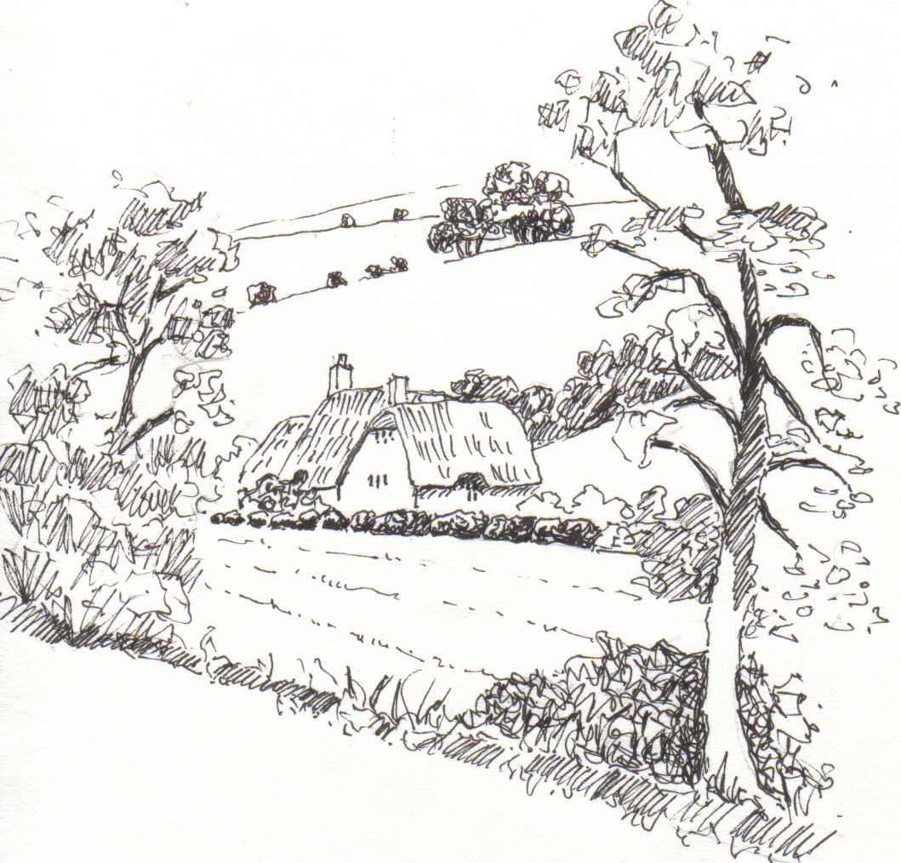

George’s Barn, Brixton Deverill
by Pat Armstrong

August 2009

Look inside for local information

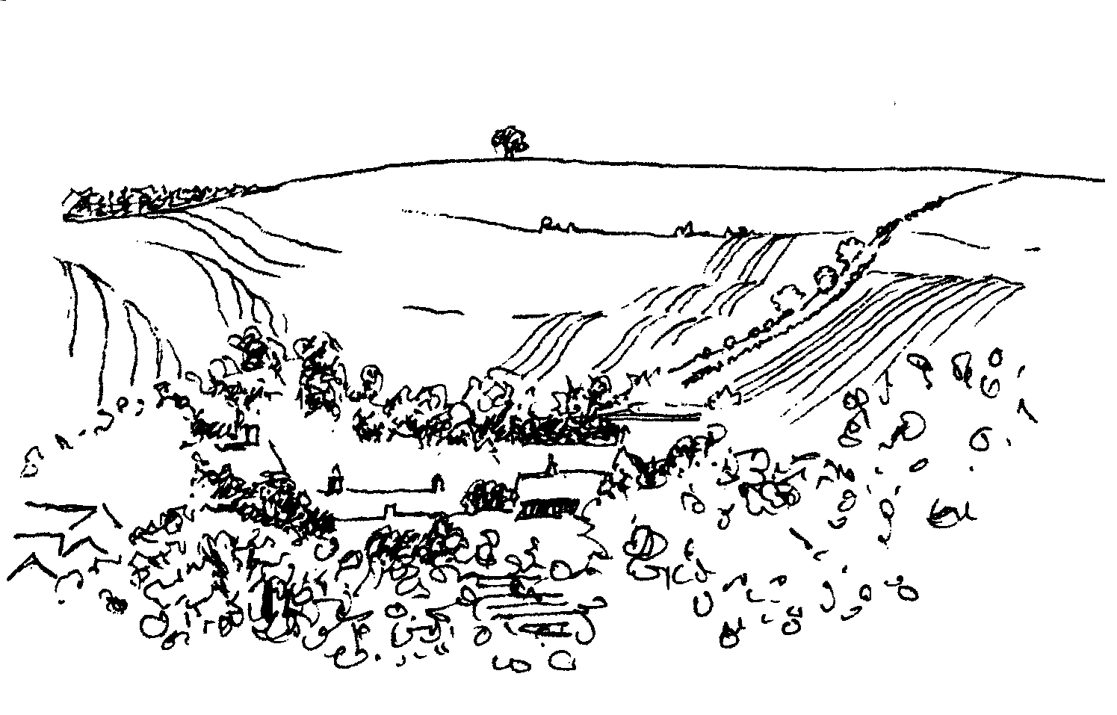
-2-

Music in the Deverills Saturday 1st August 8.00 pm
4-4 Jazz band
St Michael’s Church, Brixton Deverill Tickets £10 (inc. glass of wine)
Pre - concert supper 6.30 pm
Manor House Brixton by kind permission of Johnny & Pony Burridge
Tickets £10 (inc. glass of wine) Call 01985 840877
Cheques payable: PCC Deverills & Horningsham - profits Deverill Churches Fabric Fund

, Cards and Chat
Come and enjoy looking at the new range of cards,
ribbons, wrapping paper, and other exciting items
displayed by John and Maddie Goodden
in the Upper Deverills Village Hall on Thursday 19th February
between 10.30 and 12.00 noon - everyone is welcome
Donations will be made to the hall and the church

STOURHEAD HORSE & DOG SHOW
Sunday 2nd August - A great family day out!

Trade stands, a bar, food stalls, etc.
Many horse competitions and show jumping,
fancy dress, dressage and carriage driving

Enter your own dog on the day from 2.00 pm in any of the dog classes! The show open from 9.00 am to after 4.30 pm
www.stourheadshow.co.uk



The Royal British Legion Poppy Appeal
Gillingham Military Music Tattoo & Beating Retreat
At Gillingham School Playing Fields,
School Road, Gillingham, Dorset
Saturday 22nd August
Opening Fanfare at 7.00 pm
Wild Elephant Conservation in Thailand
An illustrated talk by Belinda Stewart-Cox and
Exhibition of pictures painted by elephants

Talk: 7.30 pm Friday 28th August
at Bull Mill, Crockerton
Ele-Art Sale: Saturday & Sunday
29th & 30th August and 5th & 6th September
10.00 am - 4.00pm
Weekdays by appointment call 840877 or 212716
All profits to the Elephant Conservation Network
For the Elephant
Conservation
Network
-3-

From the Rector:
Every three years the clergy of the Diocese gather for a conference. Thus the end of June saw a great exodus from Salisbury Diocese to the conference centre at Swanwick, Derbyshire. The main focus for our time together was Well-being. Three keynote speakers shared their areas of expertise on different aspects of being ‘Fully Alive!’ the theme first introduced to us by Timothy Radcliffe during Lent this year.
On the first evening, Baroness Susan Greenfield spoke on the topic of ‘The Neuroscience of Being Human’, a subject that, in anticipation, seemed very heavy after a long drive! However, it was a wonderful presentation, beautifully argued, and wonderfully logical. It dealt with questions about the activity of the brain, about impairment, about connections, about what happens when we learn new skills and interact with others. It was truly fascinating.
The second speaker was Alison Webster. She spoke in a more reflective way about what makes us who we are, about how we understand and know ourselves. She encouraged an appreciation of the uniqueness of every person, saying that embracing uniqueness is the hardest thing we will ever do. She reflected on intimacy and growth, and how the participation in all life under God makes us fully alive.
The former Bishop of Worcester, Peter Selby, gave the third keynote address. His talk was entitled ‘Life Abundant has its Price – Atonement, Custody and the Credit Crunch.’ In some ways, what he said was the most challenging in terms of putting our Christian beliefs into practice. He gave a brief analysis of the current crisis. He went on to outline changes in the character of money, the shifts in attitudes and how markets have changed. All of what he said he then put in the context of Romans 13:8 – Owe nobody anything except to love one another.
We were given a rich feast, one that will sustain and feed for a good while to come. Hopefully, you too have discovered something that feeds and nurtures you.
Norma Payne
Back-to-Church Sunday
On Sunday 27th September, we shall be keeping Back-to-Church Sunday. This will present an opportunity to welcome back to church those who might have attended in the past. This is an invitation to put the date in your diaries and to come to worship that day. Fuller details will be available next month.

-4-
Swine Flu
In line with recent recommendations received from the Diocese, for the foreseeable future and with immediate effect, when services of Communion are celebrated in the Benefice, we will receive the sacrament in one kind only (consecrated bread). We are asked to be vigilant about hand hygiene. In due course, depending on circumstances, there may be a temporary suspension of the sharing of The Peace so that hand contact is kept to a minimum.
Norma Payne
Two church pews for sale
St Peter and St Paul’s Church at Longbridge Deverill is hoping to receive a faculty for the sale of two oak benches and their book rest fronts. They are made of oak and stand on oak boards; the wood is in good condition. The reason for the sale is to make more space near the font. The church architect says the current value of the benches is about £100. One person has shown an interest but if there is anyone else who would like to be considered please contact me.
Elisabeth Atkinson 212129
A word of thanks from the Woodcock family
I and the whole family would like to take this opportunity of writing a few words of gratitude to all those people who attended the thanksgiving service for Daphne. It was so ably conducted by Norma, even though she was not feeling at all well, she certainly gave Daphne a wonderful send off. The Church looked beautiful. This was due to the unstinting hard work of the ladies of the flower rota with the assistance of the Wylye Valley Flower Club members. The Village Hall was also decorated with yet more wonderful flowers that Daphne would have loved. The flowers were absolutely stunning. The tea in the Village Hall, put on by the Committee, was stupendous. It was an afternoon that the whole family will remember and treasure for a very long time. As you can imagine the postman has been very busy with his deliveries of letters and cards, for which we are eternally grateful. I have endeavoured to answer as many as possible, so if anyone has been ignored I trust you will forgive me and not take it as an offence. It just remains for me to thank this wonderful community for all their many kindnesses and support.
Ian Woodcock
Thanks for the memories
As some of you will know, my car ‘died’ trying to get up the hill from Mere to church at the end of June; so I have decided it is time I gave up driving. After 50 years of belonging to the Deverills I feel a bit bereft. Mere is a good place to live, and I shall meet some of you shopping here, so I am not quite cut off. I still have some marmalade, which I sell in aid of Save the Children, and I hope to make lots more in January. If you would like some, ring me and I will get it to you. Please continue to leave 1 lb size jam jars in the porch at Kingston church, they will reach me eventually. Thank you everybody for many happy memories.
Janet Naylor 01747 860810

-5-

Longbridge Deverill and Crockerton Parish Council
At our July Parish Council meeting we received reports of cars racing through Crockerton and pedestrians feeling threatened by the actions of these drivers. The police have been informed, but it is important that the registration numbers of these cars are obtained so that they can take action. If you have been involved in any of these occurrences, or see one in the future, please advise the Police as soon as possible. (See p11 for more information ‘car racing’.)
The two Parish Greens in Crockerton are now being mowed and looked after by the Parish Council, but the Parish Steward still comes to our villages once a month. If you see any small jobs that need doing, such as clearing footpaths or filling in potholes, let us know and we can arrange for Shane to do them.
Our next meeting is on Monday 7th September in Longbridge Village Hall and, as always, members of the public are very welcome to attend.
Helen Few - Parish Clerk
Upper Deverills Parish Council
The minutes from the Annual General Meeting which took place on 8th July are displayed on the village notice boards with the minutes of the subsequent meeting. The date of our next meeting is Wednesday 9th September in the Upper Deverills Village Hall; members of the public are very welcome to attend.
Upper Deverills Parish Archive
The idea of a parish archive was mooted by the office of the Area of Outstanding Natural Beauty (AONB) a couple of years ago and several people came together under the umbrella of the Upper Deverills Parish Council to do various bits of work. These included research into the alignments of the local Roman and lead roads, surveys of river mammals, bringing together the names of the fields surrounding us, researching the ownership and use of buildings, and much else. Other work intervened and the impetus died. The Parish Council has now asked me to see if it is possible to build on the work already done and take it forward.
I am contacting those previously involved and would be delighted to hear from others who would really like to contribute their knowledge and experience for the rest of us to use and enjoy. It could be that enabling this work to be structured, published and stored in aid of a larger project would add relevance and enthusiasm. Ideas here include the preparation of a Parish Plan which sets out how we wish this part of the valley to be both protected and developed, contributing to the Victoria County History of Wiltshire (see June Parish News), and assisting in the technical wildlife surveys that contribute to land management policy and practice.
I have been asked to report back to the Parish Council in September. Stand by for a call from me! Even better, please contact me to express your interest either broadly or in a specific subject area.
Michael Mounde 844363 or mounde@talk21.com

-6-

Pre-school children & parents ‘Thursday’ group
We are closing for our summer recess on Thursday 6th August and re-opening on Thursday 3rd September from 10.00 - 11.30 am at Longbridge Deverill Village Hall. We have just completed our ninth year and are always looking forward to welcoming new parents/carers with children, under 5 years old, to join our happy group. For further details please contact Barbara on 844995 or Sylvia on 214825. We look forward to hearing from you.
Wylye Tennis Club
Now we are just over half way through our Chippenham & District League fixture programme, and better news! Our Mixed 'A' team are now (30th June) second in Division 2 and our Mixed 'B' have played off the bottom of Division 5 to 5th position - helped by a win at Grittleton and drawn matches against Chippenham and Freshford. The Ladies are also off the bottom of their division, so we hope progress continues from here on. But more importantly - we enjoy it! Ex-match cans of 4 balls are still available at £2-00 per can.
Colin Singer 213696
Save the Children Fund
Cream teas and open garden in aid of Save the Children will be held at Mill Farm House, Hill Deverill on Sunday 30th August between 3.00 – 6.00 pm and on Sunday 27th September. Do come and join us for an enjoyable and relaxing afternoon in the barn.
Anne Hurd
Deverill Valley & Crockerton Women's Institute
Honeybees
WI members are proud that Hindon and Fonthill WI's resolution 'SOS for honeybees' made it on to the AGM agenda at the Albert Hall last month and was passed by 99% majority. I thought that anyone finding a swarm of bees may need information from the June issue of WI NEWS by looking at the following website www.thewiltshirebeekeeper.com or phoning 07974 108625. If a swarm of honeybees lands in your garden or on your house, please call Fred Swift, the Wiltshire Beekeeper, he will arrange for them to be collected and re-located. If a Pest Control company is called the bees may be sprayed and killed. Help us save the honey bee.
As well as doing what we can for bees WI members nationally are also involved in supporting two previous mandates, ie Ending Violence Against Women and Care not Custody( for the mentally ill). If these wider aspects of the WI movement do not appeal to you, remember you will be warmly welcomed and find friends at any of our local meetings. This month, on Monday 10th August at 7.30 pm at Longbridge Deverill Village Hall, we shall see and hear about wildlife on Ascension Island.
Jill Russell 840209

-7-

Deverill Valley Clarinet Quintet Concert
At Longbridge Church
8.00 pm Saturday 17th October
Tickets £10.00 phone Julian Wiltshire 844152
Pre - concert supper 6.30 pm
Longbridge Village Hall
Tickets £10.00 (inc. glass of wine) phone Janet Budgen 218203
Cheques payable: PCC Deverills & Horningsham - profits Deverill Churches Fabric Fund

SATURDAY 12TH SEPTEMBER
SUPPORT
THE WILTSHIRE
HISTORIC CHURCHES TRUST
TO TAKE PART
PLEASE CONTACT
JUDY MUNRO 844385



Longbridge Deverill Village Hall
Please make a note in your diaries of our forthcoming events; we look forward to seeing you there:
Saturday 10th October Harvest Supper
Saturday 12th December Community Carols

Upper Deverills Village Hall
Thank you to everyone who contributed to the success of the Fete and Flower Show this year. Despite rainy weather there was an excellent turnout of exhibits. The results of the competitions are as follows:
Village Hall Cup (Flowers & Vegetables) – Judy Munro
Liz Peters Cup (Handicrafts) – Dinah Barnes
WI Cup (Cookery) – Claire Johnson
Molly Walker Cup – Mandy Martyn
Junior Shield – Jemima Dufosee
‘Dog of the Day’ Cup – Maya (Hunt)
The wet conditions did not dampen the enthusiasm of people to join in the activities and enjoy each other’s company over a delicious cream tea. Thank you to all those who came along and supported this enjoyable annual event.
Dates of future events will be published in September’s Parish News.

-8-
SERVICES PARISH OF DEVERILLS & HORNINGSHAM
Sunday Trinity 8
2nd August Kingston 8.00 am Holy Communion 1662
Longbridge 10.30 am Morning Worship
Horningsham 6.30 pm Evensong
Sunday Trinity 9
9th August Brixton 10.30 am Holy Communion
Horningsham 11.15 am Holy Communion
Sunday Trinity 10
16th August Longbridge 8.00 am Holy Communion 1662
Kingston 10.30 am Patronal Holy Communion
Sunday Trinity 11
23rd August Longbridge 10.30 am Holy Communion
Horningsham 11.15 am Morning Prayer
Brixton 6.00 pm Evening Prayer
Sunday Trinity 12
30th August Corsley 10.30 am Benefice Service
Showground 5.00 pm Songs of Praise
Sunday Trinity 13
6th September Brixton 8.00 am Holy Communion 1662
Longbridge 10.30 am Morning Worship*
Horningsham 6.30 pm Evensong

*Commissioning Service for Carol Clough, Head Teacher of Crockerton School

Tuesday, Wednesday, Thursday, Friday Longbridge 8.30 am Prayers
Wednesday Longbridge 10.15 am Holy Communion

The Deverills & Horningsham Register
Wedding at Longbridge Graham Few & Angela MacDonald - Saturday 11th July
Wedding at Kingston - Charles Webster & Tamara Mole Saturday 25th July

The Deverills & Horningsham Register
Wedding at Longbridge Graham Few & Angela MacDonald - Saturday 11th July
Wedding at Kingston Charles Webster & Tamara Mole Saturday 25th July

Contact the Clergy
Please contact Norma Payne (841321) or Di Britten (01373 832515) if anyone is housebound and would like communion or a visit at home;
or if someone is ill and needs our prayers; or to discuss any church matter.
Office administrator phone 210149 or email: office@cleyhill-team.org.uk

-9-
SERVICES PARISH OF CORSLEY & CHAPMANSLADE
Sunday Trinity 8
2nd August Corsley 9.00 am Holy Communion
Sunday Trinity 9
9th August Chapmanslade 9.00 am Holy Communion
Temple 11.00 am Morning Prayer
Sunday Trinity 10
16th August Chapmanslade 9.00 am Holy Communion
Corsley 6.00 pm Prayer & Praise
Sunday Trinity 11
23rd August Temple 9.00 am Holy Communion 1662
Corsley 10.30 am Parish Service
Sunday Trinity 12
30th August Corsley 10.30 am Benefice Service
Showground 5.00 pm Songs of Praise
Sunday Trinity 13
6th September Corsley 9.00 am Holy Communion
Parish Prayer groups - These monthly groups will meet in August as follows:
In the Deverills and Horningsham on Tuesday 4th August from 7.00 pm to 8.00 pm at the Frog Lane Barn, Longbridge, to pray particularly for our communities.
In Corsley and Chapmanslade, on Sunday 16th August at 6.00 pm in St. Margaret's Church, Corsley, for Prayer and Praise.

Ivy House St Denys Retreat Centre
Sunday 16th August - Garden Quiet Day
Monday 24th August - House Quiet Day
To book and for more information please phone 214824
Ivy House St Denys Retreat Centre
Sunday 16th August - Garden Quiet Day
Monday 24th August - House Quiet Day
To book and for more information please phone 214824

Church Cleaners for August
Kingston - Mrs Beilby & Mrs Noonan
Brixton - Mrs Fry & Mrs Staniland
Longbridge - Monday 3rd August 9.30 - 10.30 am - all helpers please
Church Flower Arrangers for February
 | Kingston | Brixton | Longbridge
2nd Aug | Mrs Heywood | Mrs Hammick | Mrs Stepto
9th Aug | Mrs Heywood | Mrs Hammick | Mrs Atkinson
16th Aug | Mrs Blair | Mrs Marsh | Mrs Atkinson
23rd Aug | Mrs Blair | Mrs Marsh | Mrs Young
30th Aug | Mrs Goodden | Mrs Burridge | Mrs Young

-10-

Paper for Parish News
Thank you to those who have donated paper for printing the Parish News during the year, it is very much appreciated and helps enormously to keep the production costs down.
Community Spirit
Many of you will have noticed the great improvement to Monkton Green and the verge of the B3095 when approaching Monkton from Kingston. At first, we thought it was the work of the Council, but no, it turns out that the provider of the seats, planter of flowers, mower of grass, is Monkton resident Colin Smith. We reckon his community spirit makes him a real ‘local hero’.
Muiris Carrick & Christie Burton
Neighbourhood Watch

There have been two incidents during June concerning Monkton Deverill residents. In the first a resident was persuaded by two plausible young men to allow them to work in the garden after which they presented a very large bill. It was a very difficult situation, a payment had to be made, and the work had not been done satisfactorily. The police warn that variations on this kind of deception are occurring locally. Some incidents have, unlike this one, resulted in the residents being conducted by the ‘travelling tradesmen’ to the bank to draw large cash sums as payment for poor work. The police offer the following advice. If the people attending your house have no identification, do not let them in. If they then show some identification, ask them to hand it to you, whilst they wait outside so you can ring the company they are from to confirm they should be there. Any reputable company should ring you prior to their personnel attending your house. If you feel threatened ring 999. If you are in any doubt send them away but where possible make a note of their description and the registration number of the vehicle they are using and phone 0845 408 7000 with this information. It is better to use reputable and locally based trades people. Avoid being rushed into a quick, cheap job which may turn out to be quite the opposite.
The second incident was later in the month when a resident was briefly visiting Kingston Deverill church and left a handbag where it could be seen, in an unlocked car. It was stolen and its loss has caused considerable upset and inconvenience. This is the second case of a handbag being stolen in the vicinity of Kingston church recently and seems to have been the work of opportunist thieves. The police advice is that if we cannot take valuables with us, then we should place them out of sight and lock our unattended vehicle. These incidents are being investigated by our Neighbourhood Beat Team, but please be aware of dishonest people seizing opportunities to steal from or take advantage of older residents in our area.
Albert Lee

CONTACT THE EDITOR AND WEBSITE
Parish News Editor - Judy Munro 844385
Contributions for the Parish News through my letterbox or
by post to Whitepits Lodge, Kingston Deverill, Warminster,
BA12 7HD or by Email: judymunro@tiscali.co.uk Thank you
Please remember the deadline is the 15th of every month

Website: www.deverills.org.uk Email address:info@deverills.org.uk
Website manager : Kate Wilkinson 844998
Contents: Parish News with church services, Parish Register, Events, Local News plus pictures and other information
-11-

Police Community Support Officer
Shearwater
Visitors to Shearwater Lake, Crockerton, are kindly reminded that there are ‘no stopping’ signs for a mile along the road next to the lake, these are clearly marked either side of the lake with repeaters along the clearway. Visitors should not park their vehicles along this stretch of the road but use the three car parking facilities around the area. Vehicles parked along the clearway may receive a £30 non-endorseable ticket. Recently there have been reports of quad bikes and trial bikes driving dangerously in and around Shearwater Lake. If members of the public see such an incident, please report it on 0845 408 7000, giving the registration numbers and descriptions of the riders.
Local Speed Checks
Warminster Police Officers have recently carried out speed checks along Cley Street, during which 3 tickets were issued, 1 disqualified driver was stopped and 25 verbal warnings were given for excess speed along this stretch of road. As speeding is one of the Warminster Rural Neighbourhood Policing Team's priorities speed checks will be carried out on a regular basis
Car Racing
There have recently been reports from residents in and around the Crockerton area of motor vehicles racing for money from Maiden Bradley along to Shearwater then onto Turnpike Cottage and finally at Centre Parcs. Vehicles have also been seen doing wheel spins, and donuts in the Heavens Gate car park. If any residents do come across or hear of such things, then PLEASE do not hesitate to contact the Police on 0845 408 7000 and pass on any details of vehicles, registration numbers and descriptions of the people involved.
Ian Owen
Maiden Bradley Community Shop (844206)
The much promised refurbishment is complete, you will not recognise us! Please come and visit the shop, see what you think. Thank you for your support.
Recipe from Sue Priestner - Onion Pudding
Onion Pudding is to Lamb as Yorkshire Pudding is to Beef.
Ingredients
3oz/85 gms self-raising flour 1 medium onion (chopped)
3oz/85 gms porridge oats 1 egg
1½ oz/43 gms margarine of butter Milk
Salt & pepper
Method
1. Mix the fat in with the flour using tips of fingers until you have a crumb mix.
2. Add the oats, egg, onion and gradually add milk until fairly sloppy, not stiff.
3. Add salt and pepper to taste.
4. Grease a shallow dish and pour in the mixture.
5. Bake for 40-45 minutes 180C/375F/gas 5 till golden brown, check with skewer.
6. Cut into slices and serve.

-12-

Where have you been?
The King’s Arms, Charlton Horethorne, Sherborne
(01963 220281 and www.thekingsarms.co.uk)
“We’ve been to the most marvellous pub to eat” I heard one ‘lady-who-lunched’ saying to another in the pickles and olives aisle at Waitrose in Gillingham. I sidled up surreptitiously and feigned interest in some mustard. “Oh, I think I know where you mean…” her companion answered as they drifted into herbs and spices. I continued to follow, hoping they would mention the name of this wonderful place. They continued to sing its praises all around bread and tea until in breakfast cereals I cracked and in the interests of the readers of this magazine I asked them if they could tell me the name of the place they were discussing. Neither of them could remember the name of the pub or the village it was in but when they described it as ‘after Wincanton on the way to Sherborne’ and its position in the village we all knew where we meant even though none of us knew what it was called!
The King’s Arms at Charlton Horethorne looks like a small country hotel from the outside, possibly 18th or 19th century, but inside it is a different story. It is modern and spacious with a polished granite bar and tiled floors. The owner is Tony Ledbridge who used to run The Compasses at Chicksgrove and then The Three Horseshoes at Batcombe. Apparently the King’s Arms had been a thatched pub which burned down, apart from the front wall. As there was nothing to preserve, when he renovated the pub the owner decided to make it modern. You may or may not like that aspect of it; I confess that I do - a friend who tried it didn’t and found the staff a little too attentive. What I liked about it was the food, which I thought very good, its open, clean lines, the art work by local artists for sale on the walls and the fact that dogs were allowed in the front two dining areas. The pub also has a large rear dining area and patio. I was shown around the accommodation; each room is named after a stone (e.g. onyx) and decorated accordingly. Although not huge, the rooms felt spacious because they were uncluttered and the en suites were all ‘wet rooms’. They were all beautifully done. I recommend it if you find yourself on the road from Wincanton to Sherborne and also if you are an artist in search of a wall. The owner had sold a significant number of paintings since he opened in March and is always on the look out for new stuff to display. He does take a commission but not an unreasonable one. Call him for more details.
If you have somewhere you would like to recommend, please send your comments and suggestions to me by email at farthings.kd@btinternet.com or through my letter box at Farthings, Kingston Deverill.
Trish Shuler 840834

-13-

Nature Notes
First of all, I would like to thank everyone for their get well wishes, the cards and flowers. They have been much appreciated and have definitely helped in my recovery. The stay in hospital made me realize the beauty of our countryside around here even more and it was so good to get back home. I missed most of May but have been keeping an eye on the birds since and I am sure that this summer they have had a good breeding season as I have seen young of most species, a stark contrast to last year when the weather was so awful.
The blackbirds have done very well with several broods and I have seen and heard young being fed by both parents. The young are very persistent following the parent begging continually. I have also seen and heard families of great, blue and long-tailed tits. We have had young robins and I think young wrens judging by the scolding of the adults; I have not actually seen a young wren but the parents are obviously protective. Young sparrows, house and tree, we have seen, together with young greenfinches and chaffinches. Also we have had young goldfinches visiting the feeders. A young goldfinch lacks the red on the head of an adult and can be mistaken for a chaffinch but it has the distinctive black and white pattern on the folded wing. We have also had great spotted woodpeckers with young. The youngsters have a red cap on the head. One day I saw the male woodpecker with a youngster on the nuts on the shed and he was feeding it though it looked big enough to feed itself! We have kept ‘our’ siskins and they have had young. We normally only have siskins visit in the spring and then they go off, this year they have decided to stay. Today there are young magpies in the garden. I had wondered why the feeders were quieter than usual. It is clever how all the birds know when a predator is about; they have a very good ‘grapevine’ and all recognize the alarm calls for danger. The swallows and house martins are doing well too. The swallows in the garage are now on their second brood. We have got four house martin nests occupied at the front of the house and two broods have flown already.
Birds are not the only thing to be doing well on the farm, there have been lots of hares which have produced a good number of leverets. I never tire of watching hares and love seeing them in their classic pose sitting up with one ear forward and one ear back. The field behind the house is covered in clover which has attracted lots of insects particularly bees. Up in the beeches at the top of the farm there are three bee nests which have been very active in the warm weather. In the middle of the clover field there is a badger sett. One evening well before dusk during the very hot weather a badger was out foraging in the clover, probably looking for beetles and other food above ground, as it was unable to dig for its normal food the earthworm. The ground had become so hard and the earthworms had gone deeper into damper soil, this recent wetter weather will have improved things for digging.
One thing I must tell you, I saw a red kite early morning on the 15th June. That is the second time I have seen one this year on the farm. Each time I see a buzzard now I take a second look to check out the tail. The red kite has a very distinctive forked tail which distinguishes it from a buzzard, it is also bigger and the wings are narrower and of course it has a lovely red colour.
Jane Trollope (14th July)

-14-

LOCAL COUNCILS, SOCIETIES, GROUPS etc.
Longbridge Deverill and Crockerton Parish Council
Karen Manfield 215526 (Chair) Peter Whithey 840347 (Vice Chair)
Helen Few 840119 (Clerk) Thomas Minter 216909
Bill Hurd 840023 Elaine Pidgeon 212878
Julian Algar 840816 Graham Read 840296
Brian Marshall 214789
Upper Deverills Parish Council
Lady Felicity Wheeler 844683 (Chair) Ranald Blue 841374
Jacqueline Smith 840238 (Clerk) Patricia Shuler 844291
Sarah Fagan 844123 Robin Greenwood 840743
Wiltshire Councillor
Fleur de Rhé Philipe 213193

Wiltshire Council 0300 456 0100

Longbridge Deverill Village Hall Committee
Julie Read 840655 (Chair) Sylvia Titt 214825 (Caretaker)

Upper Deverills Village Hall
Richard Cousens 844970 (Chair)
Mandy Martyn 844320 (Secretary) John Lea 844325 (Hall bookings)

Crockerton Millennium Committee
Marion Thomas 213739 (Chair)

Pre-School Children and Parents ‘Thursday Group’
Barbara Beilby 844995 (Chair) Sylvia Titt 214825 (Leader)

Deverill Valley & Crockerton W I
Ruth Sutton (President) Jill Russell 840209 (Secretary)

Sir James Thynne Almshouse
Mrs Sue Jackson 840322 (Steward)

Deverills Cricket Club
Jamie Fagan 844123 Peter Child 01963 34593

Wylye Valley Tennis Club
Colin Singer 213696

Wylye Valley Flower Club
Mrs Hazel Yate 215617 (President) Mrs S Scott 213689 (Programme Secretary)

Wiltshire Wildlife Trust
Elm Tree Court, Long Street, Devizes SN10 1NJ www.wiltshirewildlife.org

Rural Community Beat Officer - Police Community Support Officers
PC Vicky Pegrum - PCSOs Ian Owen & Caroline Wright - 0845 408 7000

Hospital Transport Link Scheme 211655

-15-

F O R T H C O M I N G E V E N T S
Forthcoming Events

- Scottish Dancing Monday Evenings Aline Fry (841054)
- Badminton Mondays & Fridays 3.00 - 5.00 pm Alison Rymell (844819)
- Bell Ringing at Longbridge Wednesdays 7.30 pm Richard Munro (844385)
- Hearing Loss Lip-reading Wednesdays Margaret Head (213259)
- Pre-school & Parents Group Thursdays 10.00 - 11.30 am See p6/14
- New Deverill Choir Fridays 7.30 pm Claire Johnson 840787
- Jazz Concert Saturday 1st August See p2
- Stourhead Horse & Dog Show Sunday 2nd August See p2
- Parish Prayer Group Tuesday 4th August See p9
- Women’s Institute Evening Meeting Monday 10th August See p6
- Wylye Valley Flower Club Demonstration Tuesday 11th August See p14
- Ivy House Garden Quiet Day Sunday 16th August See p9
- Deverills Cricket Club Sundays 16th, 23rd, & Monday 31st August See p14
- Gillingham Military Tattoo & Beating Retreat Saturday 22nd August See p2
- Ivy House Quiet Day Monday 24th August See p9
- Wild Elephant Conservation in Thailand Talk Friday 28th August See p2
- Ele-Art Sale Saturday 29th & Sunday 30th August See p2
- Save the Children Teas and Open Garden Sunday 30th August See p6
- Pre-school & Parents Thursday Group restarts 3rd September See p6
- Ele-Art Sale Saturday 5th & Sunday 6th September See p2
- Deverills Cricket Club Sunday 6th, 13th September See p14
- Longbridge & Crockerton Parish Council meeting 7.30 pm Monday 7th September at Longbridge Village Hall See p5/14
- Upper Deverills Parish Council Annual Meeting 7.30 pm Wednesday 9th September Upper Deverills Village Hall See p5/14
- Churches Cycle Ride Saturday 12th September See p7
- Back to Church Sunday 27th September See p3
- Save the Children Teas and Open Garden Sunday 27th September See p6
- The George, Longbridge, Pumpkin, Beer & Cider Festival 2nd - 4th October
- Longbridge Village Hall Harvest Supper Saturday 10th October See p7
- Deverill Valley Clarinet Quintet Concert Saturday 17th October See p7
- Longbridge Village Hall Community Carols Saturday 12th December See p7

F O R T H C O M I N G E V E N T S
16-
PARISH OF DEVERILLS AND HORNINGSHAM
Contact the Editor and the Website

Parish News Editor: Judy Munro 844385
Contributions for the Parish News through my letterbox or
by post to Whitepits Lodge, Kingston Deverill, Warminster,
BA12 7HD or by Email: judymunro@tiscali.co.uk Thank you
Please remember the deadline is the 15th of every month

Website: www.deverills.org.uk
Email address: info@deverills.org.uk
Website manager: Kate Wilkinson 844998
Contents: Parish News with church services, Parish Register, Events,
Local news plus pictures and other information
Churches
SS Peter & Paul the Apostles Longbridge Deverill
St Michael the Archangel Brixton Deverill
St Mary the Virgin Kingston Deverill
St John the Baptist Horningsham
Rector
Rev Norma Payne, 6 Homefields, Longbridge Deverill 841321
Clergy
Rev Diana Britten, 69 Lane End, Corsley 01373 832515
Licensed Lay Ministers
Mr John Budgen 218203
Col Robin Chappell 212153
Churchwardens
Mrs Elisabeth Atkinson (Longbridge Deverill) 212129
Mrs Mary Stewart Cox (Brixton Deverill) 840877
Major Mike Tulloch (Kingston Deverill) 844381
Mr Tim Moore (Horningsham) 844336
PCC Treasurer Mr David Stratton 844549
PCC Secretary Mr Nigel Poole 840902
Church Electoral Roll Officer Major Mike Tulloch 844381
Parish News Editor Mrs Judy Munro 844385
Organist Mr John Budgen 218203
Bell Tower Captain - Longbridge Mr Steven Young 212796
Caretaker - Longbridge Church Mrs Sylvia Titt 214825
Office Administrator Mr Dick Collins 210149
(Mon -Thurs 10.00 - 12.00) 22 Church Street, Warminster

